DPFM

Component Site (ESB, FGD, FSB, NHT, ) | ESB - Cummins Emission Solutions
Application Name | DPFM
Manufacturer | Cummins Inc
Version | 6.1.8
Unique Identifier Name | DPFM_Service_Tool.exe
Unique Identifier Size (bytes) | 537600
Application Certifier (responsible for testing) | Tony Sheets
IT Application Owner | Kerang Wang

** Note **

NELSON LABS PREREQS is a Prereq for this app.
Installation Instructions
Right click the file kvaser_drivers_setup.exe located "DPFM\Media\kvaser_drivers_setup.exe"
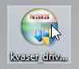

Select “Run as administrator”
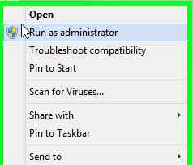

Click Next
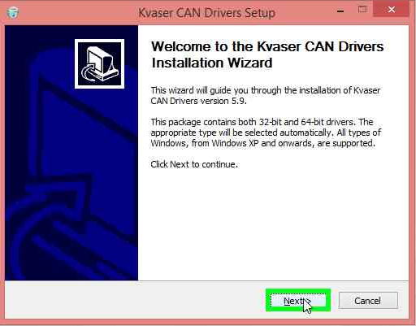
Click Next again
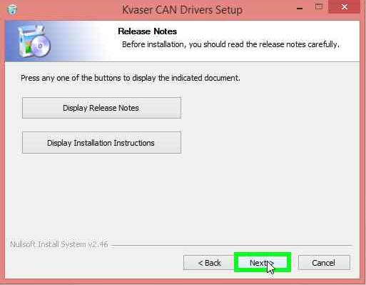
Check all three boxes and click Next
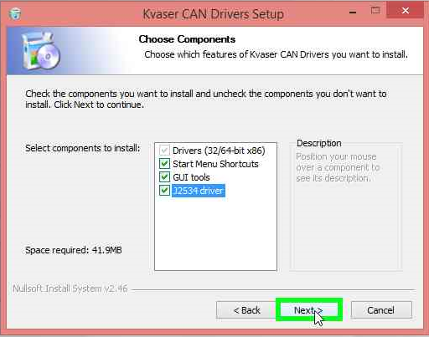
Change the install path to C:\Software\Kvaser\Drivers then click Install
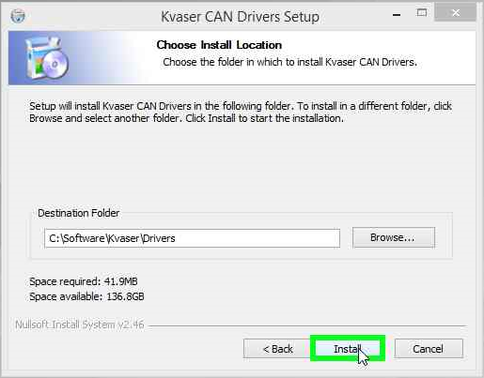

Click Install again

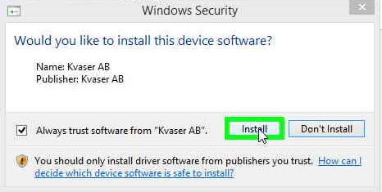

Click Close
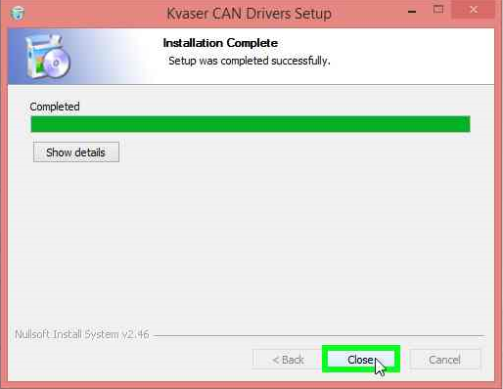

Right click CMNS32_Install.bat
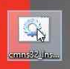

Select “Run as administrator”
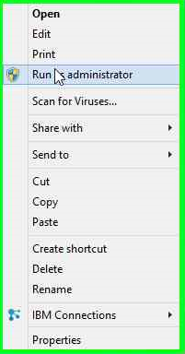
There is no confirmation, when it is complete a command window will automatically close.

Right click the file DPFM.msi
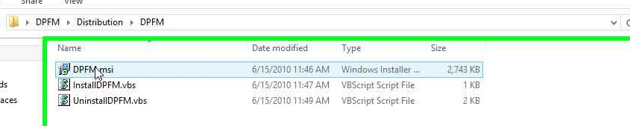

Select Install
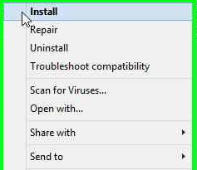
Click Next
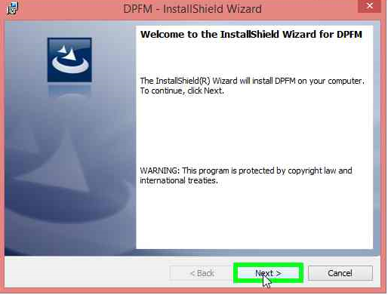

Click Finish
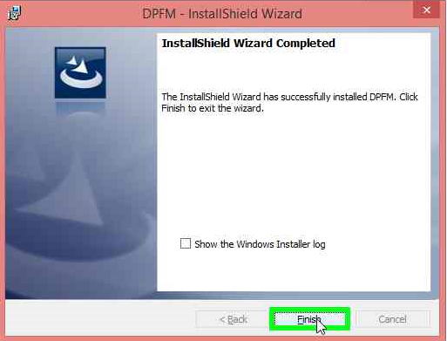

Additional Information:

